Management Information System for
Faculty of Technology

ICT2123

Group No. 9

Lecturer in Charge: Ms. Chanduni Gamage

Submission Date: 5/27/2022

By,
R. M. S. C. Bandara TG/2019/500
A.P.G.G. Chiranjitha TG/2019/506
G.K. Dulanjana TG/2019/524
Lakshi Vihanga TG/2019/501
L.G. N. Sewwandi TG/2019/520



Bachelor of Information and Communication Technology

Department of ICT

Faculty of Technology

University of Ruhuna

Contents

Introduction 3
Functional requirements of the system 4
Non-Functional requirements of the system 5
ER Diagram 6
Class Diagram 7
Interfaces Of the System 8
Problems we have encountered during the development of the system 9
Solutions we have identified 9
Technologies we used 9
Individual Contribution 10
References 11

Introduction

Management Information System is a system which manage information of its users and manage data. As the mini project of Object-Oriented Development, we have developed a management information system called ‘TECMIS’ for University of Ruhuna faculty of Technology. There are four main types of users like admin, lecturer, technical officer, student who use this system. According to the type of user the functionalities of the system get different and area which they can cover is different. Every user of the system has their own login accounts and those accounts secured by the passwords. As the view of ours, this system may be the best platform to manage information of nearly thousand students of the faculty and most efficient and secure way of publishing announcements, releasing exam results, submitting medicals etc. The main objective of this system is to enhance functionality of the current working MIS and provide a better service and provide better support for the users to do what they want and to reduce the consumption of time during maintaining the records of university. Separate logins are provided to maintain the records of lecturers, technical officers, students, and administrator

Functional requirements of the system

- Admin should be able to create and maintain all user profiles, create, and maintain courses, create, and maintain notices, create, and maintain timetables.

- Lecturer should be able to update their profile except username and password modify and add materials to courses, upload marks for all kind of exams, see student details, see student eligibility, see student marks, grades, and GPA, see attendance and medical records of students, and see notices.

- Technical officer should be able to update their profile except username and password, add and maintain attendance details of students, add, and maintain medical details of students, see timetables of their department

- Student should be able to update only contact details and profile picture of their profile, see attendance details, see medical details, see their course details, see their grades and GPA, see their timetables, and see notice

- There should be a way to check eligibility as individuals and for the whole batch.

- There should be a way to see the final marks only for individuals and whole batch

- There should be a way to see marks for each subject, student and as a whole batch

- There should be a way to see Grades for each subject, student and as a whole batch

- There should be a way to see SGPA and CGPA with the subjects and grades for each student and for the whole batch

Non-Functional requirements of the system

- Attractiveness
The system should be more attractive, and it should be able to attract users. We used colorful GUI for that.

- Protection
System should manage user logins and user accounts should be protected by the passwords. Privacy of the users is highly accepted.

- Efficiency
When any user entered usernames and passwords withing he or she should be validated withing 1 second and if there any issue regarding those things it should be display to the users.
When the user request something system should respond withing 2 or 3 seconds

- Availability
System should be available 24 hours in 365 days

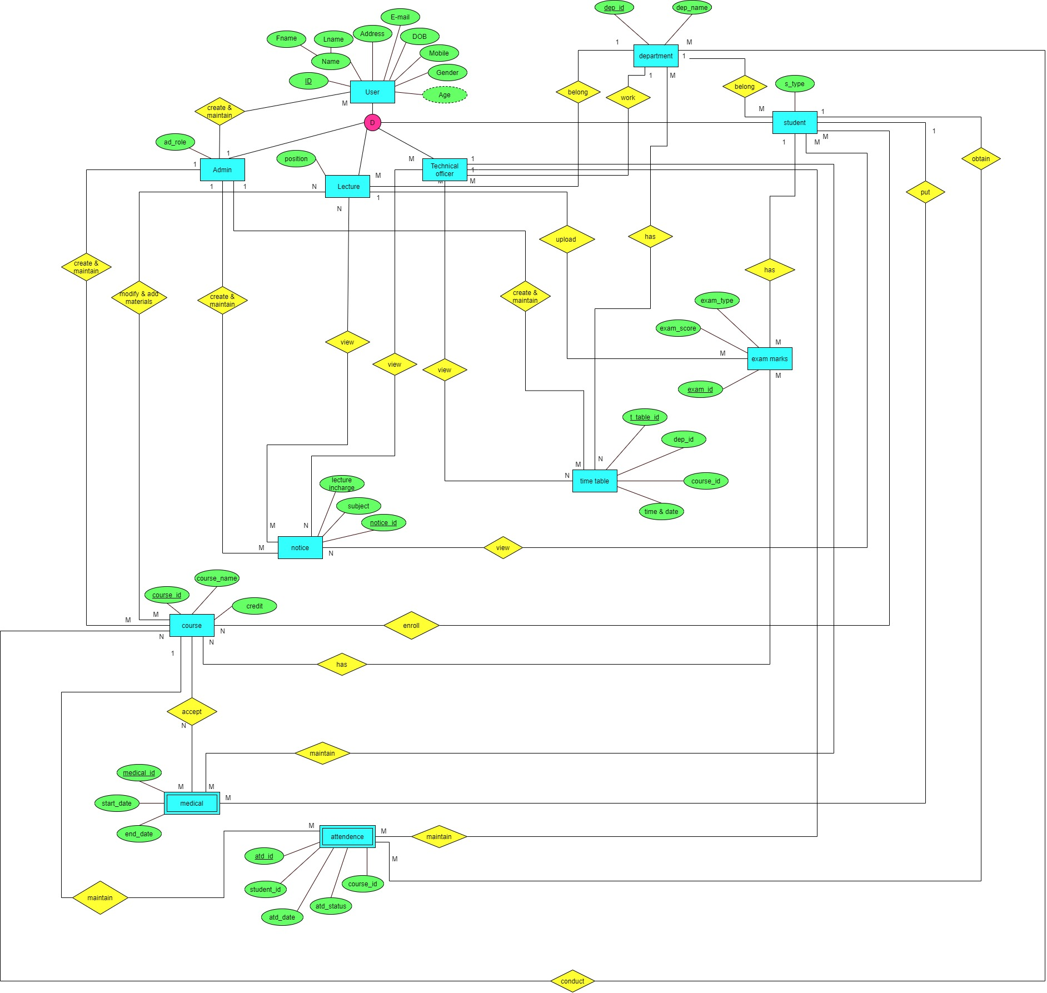
ER Diagram

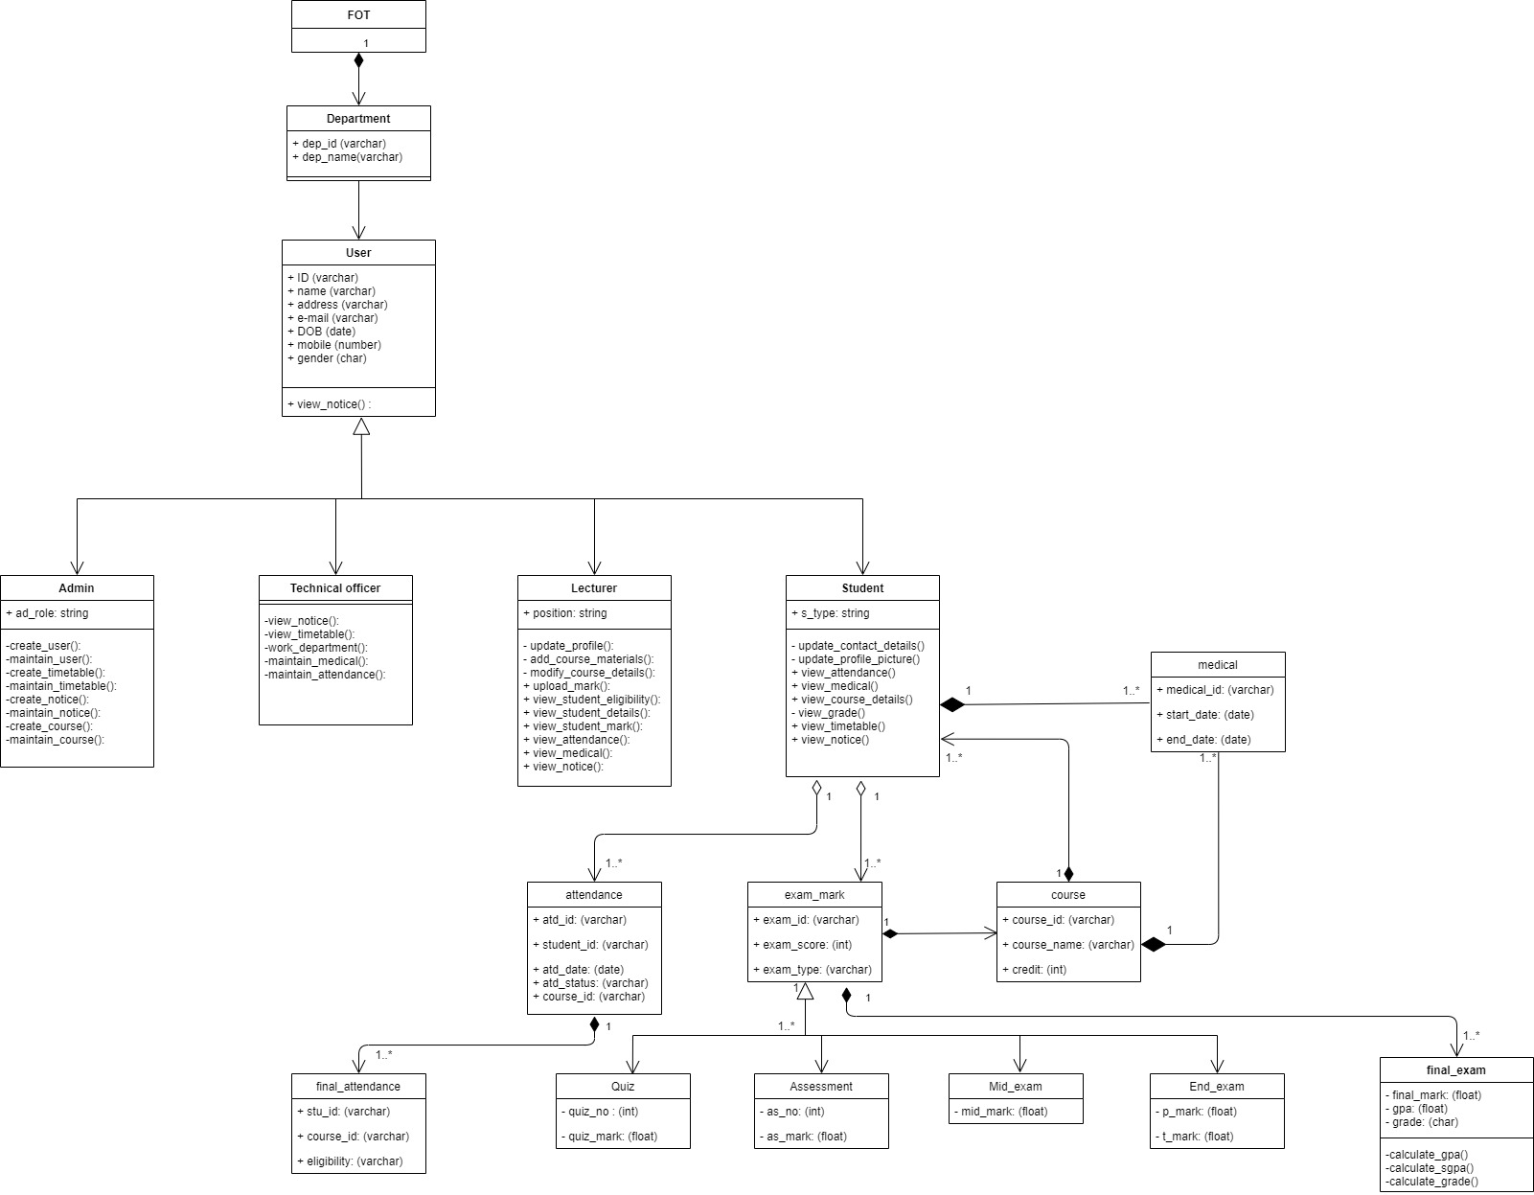
Class Diagram

Interfaces Of the System

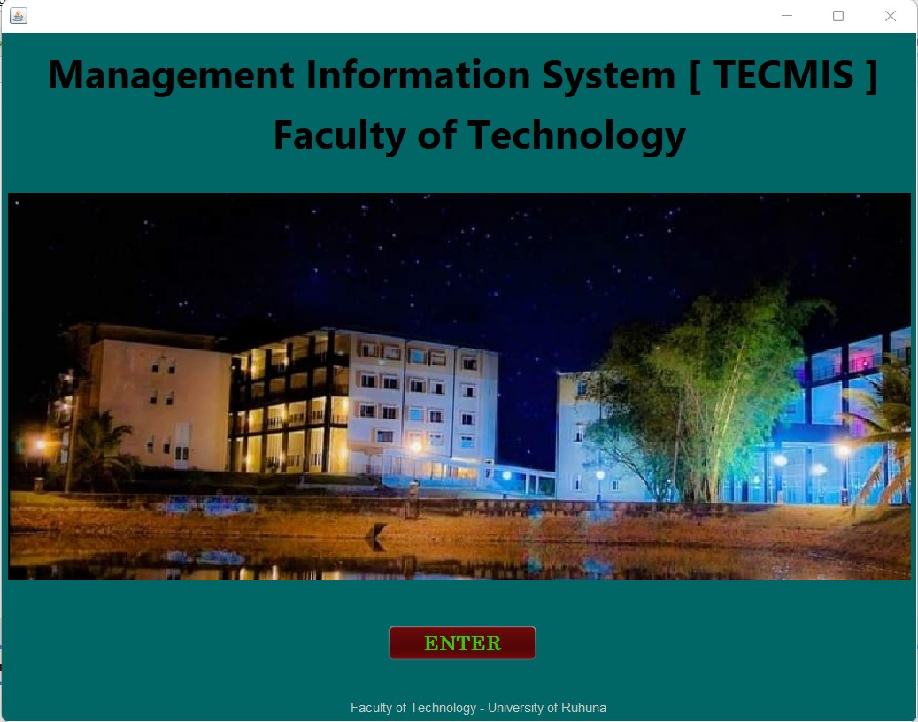

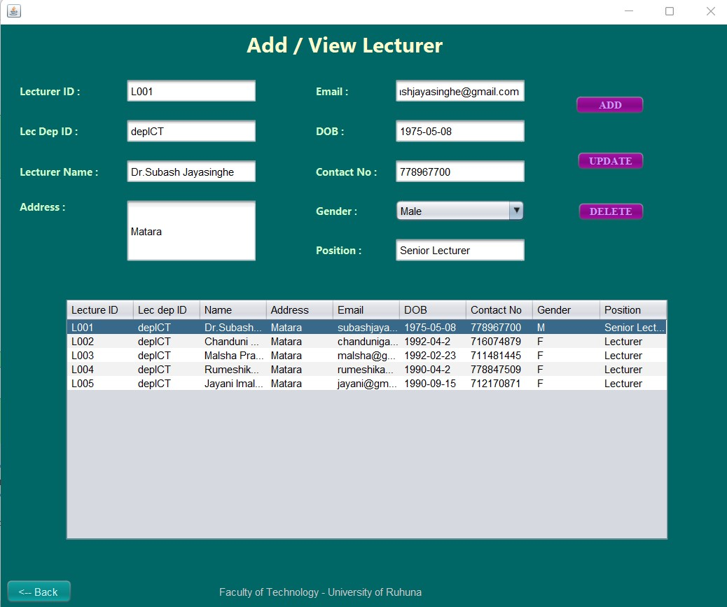

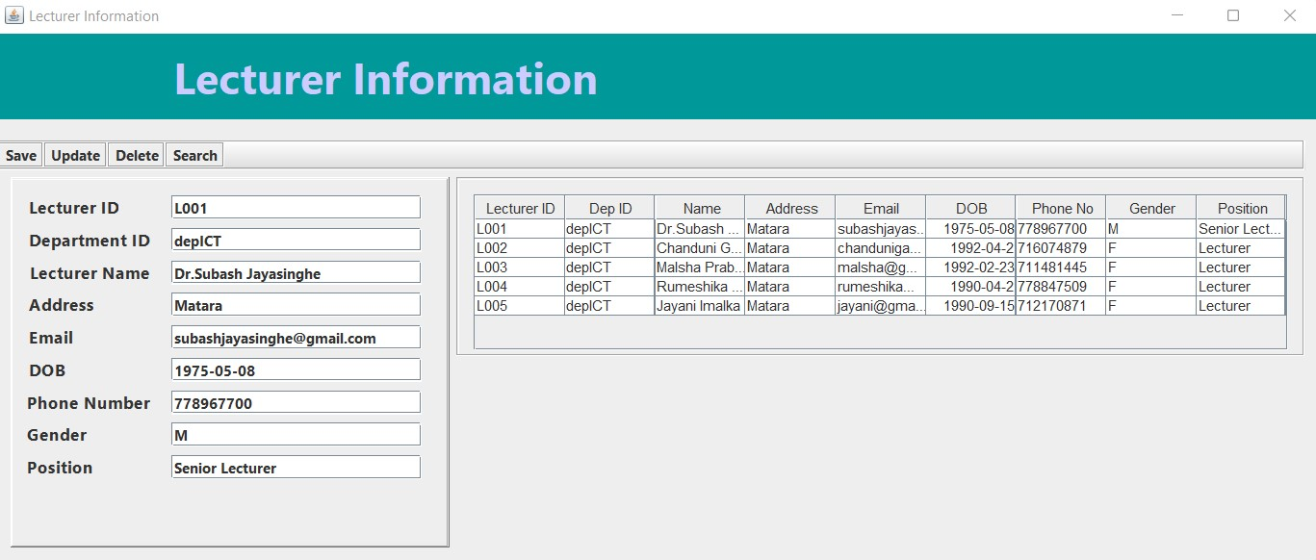
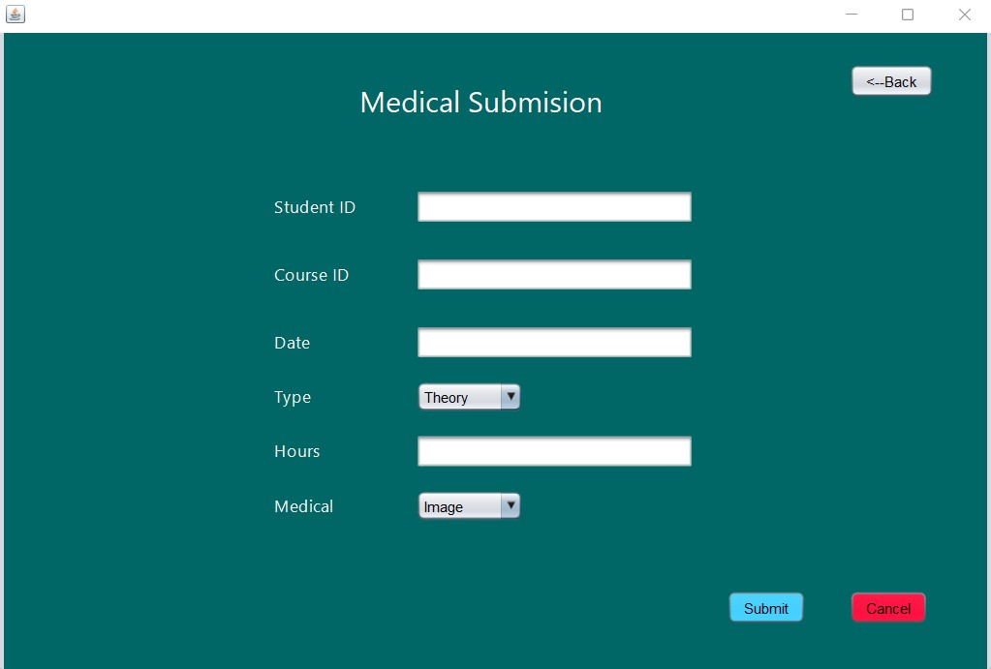

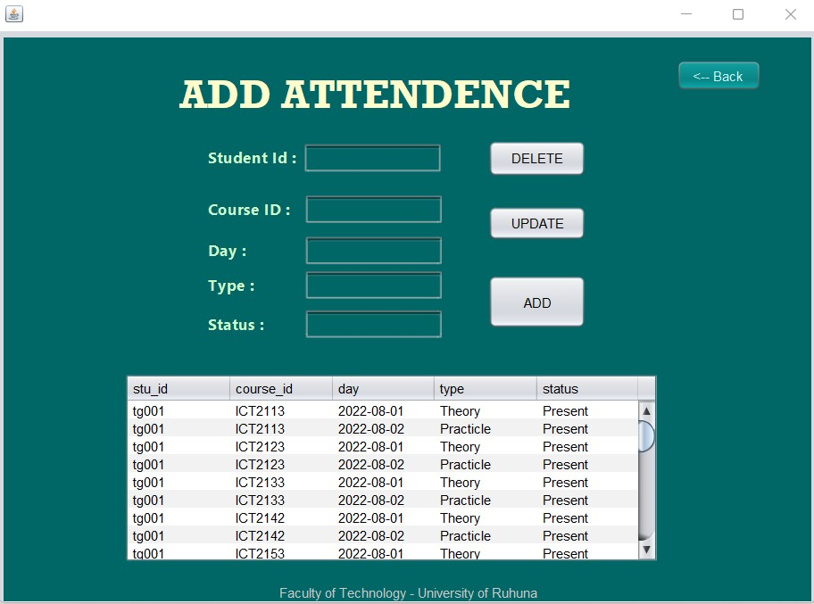

Problems we have encountered during the development of the system

- We created ER and class diagrams but when developing some differences were occurred
- Calculations were difficult to do
- Some interfaces were difficult to design and there was somewhat conflict originated regarding variable names

Solutions we have identified

- Some interfaces were not suitable with the requirement, so we remove those interfaces and redesigned them
- Since there were some difficulties happened when developing according to the Er diagram, we happened to add additional records for the tables
- When calculation problems occurred, we referred some YouTube videos

Technologies we used

- Net Beans 12.1
- PHP My Admin
- Java jdk and jre 8

Individual Contribution

Name | Contribution
R. M. S. C. Bandara - TG/2019/500 | Lecturer
A.P.G. Chiranjitha - TG/2019/506 | Technical officer
G.K. Dulanjana - TG/2019/524 | Admin
L.V. Ranasighe - TG/2019/501 | Student
L. G. N. Sewwandi - TG/2019/520 | Student

References

- Assignment 01 guideline pdf which was provided by the lecture in charge
- Student rule book provided by the faculty of technology University of Ruhuna

